Documentation for push notifications api in both ios and android for whistle safety app:

Push notifications for Android was implemented using gcm push notifications.

For ios, apns was used to implement it.

For nodejs, the npm package ‘node-gcm’ was used to implement it for android, and ‘apn’ for ios.

**What are push notifications?**

It is nothing but the message notification that you receive on your phone.

Example: this uber push notification.

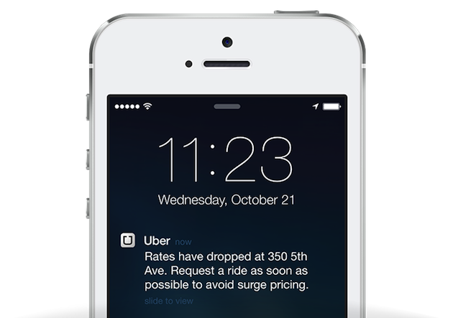

Our whistle safety app will have the same feature now.

**Here are some handy guides to help understand push notifications:**

**Ios:**

<https://eladnava.com/send-push-notifications-to-ios-devices-using-xcode-8-and-swift-3/>

**Android:**

[**https://developers.google.com/cloud-messaging/concept-options**](https://developers.google.com/cloud-messaging/concept-options)

## How to send push notifications via push notification API?

**Important: For any api call given below authentication is required to do any work.**

**So, please give Authentication token in the request header.**

Step 1 : register your device for push notifications:

|  |  |  |  |
| --- | --- | --- | --- |
| Request | url | Request body | result |
| PUT | /api/devices/register | **1.phone** ex: “+918056060313”  **2.platform** “android” or “ios”  **3.registrationId**  device token obtained by registering the device to the required provider(apn or gcm)  **5.deviceId** device id  **6.deviceName** device model name:  Ex: Apple Iphone 7s | Registers device in order to receive push notification |

Step 2 : create a **producer** whistle of category **‘community-help’** from your device.

Follow the steps given in the link: [Create Whistle](http://docs.whistle.apiary.io/#reference/whistles/whistle/create-a-new-whistle)

Step 3 : give the following api call:

|  |  |  |  |
| --- | --- | --- | --- |
| Request | url | Request body | result |
| POST | /api /panic | **1.radius** radius of search  **2.limit** no.of results | Crestes a consumer panic whistle of category: ‘community-help’ and Sends push notification to available devices |

This step automatically creates a panic whistle ( which is a **consumer** whistle of category **‘community-help’** )

**Note : the first 2 steps are implemented in the whsitlesafety app.**

**The last step happens when we press the panic button in the app.**

When we press panic button, a consumer whistle is created with category ‘community-help’ and also gives push notifications to all nearby devices within a given radius, who have registered their devices and have created a ‘community-help’ producer whistle.

**So, in order to receive push notifications, the device should first register itself and create a producer ‘community-help’ whistle.**

All API methods:

Device CRUD:

**ALL API REQUESTS NEED AN AUTHENTICATON TOKEN TO FUNCTION PROPERLY**

|  |  |  |  |  |  |  |
| --- | --- | --- | --- | --- | --- | --- |
| Request | url | | Request body | | result | |
| GET | /api /devices | |  | | Displays the list of all registered devices | |
| PUT | /api/devices/register | | **1.phone** ex: “+919876543210”  **2.platform** “android” or “ios”  **3.registrationId**  device token obtained by registering the device to the required provider(apn or gcm)  **5.deviceId** device id  **6.deviceName** device model name:  Ex: Apple Iphone 7s | | | Registers device in order to receive push notification |
| POST | /api/devices/edit/<phone>  Example:  /api/devices/edit/+919876543210 | | | Same params as registering device,  But you can give a subset of all the 6 parameters too. | Edits the device, and updates the given body params | |
| DELETE | | /api/devices/<phone>  Example:  /api/devices/+919876543210 | |  | Deletes the given device | |
| POST | | /api/devices/clear | |  | Removes all devices.  (be careful)  ***This feature is only for testing purpose and will be removed, once in production. | |

Panic whistle and push notifications:

|  |  |  |  |
| --- | --- | --- | --- |
| Request | url | Request body | result |
| POST | /api /panic | **1.radius** radius of search  **2.limit** no.of results | **Crestes a consumer panic whistle** of category: ‘community-help’ and **Sends push notification** to available devices |

**NOTE:**

Be careful about the phone field, during registering and editing the device.

Make sure that you give the exact phone that you gave while [create new user](http://docs.whistle.apiary.io/#reference/users/account/create-new-user-account), because this device will be mapped to the user, via phone attribute**.**